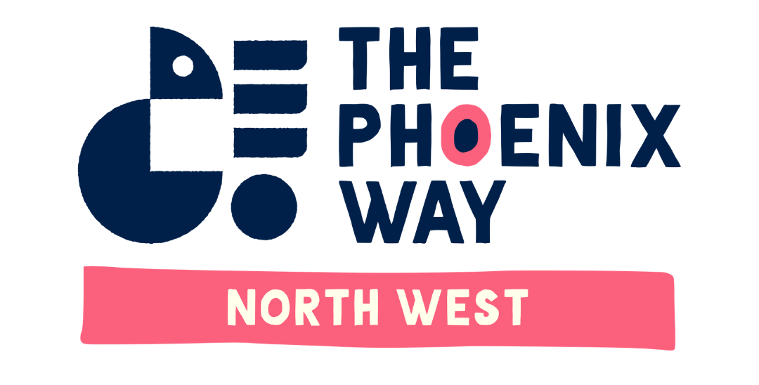

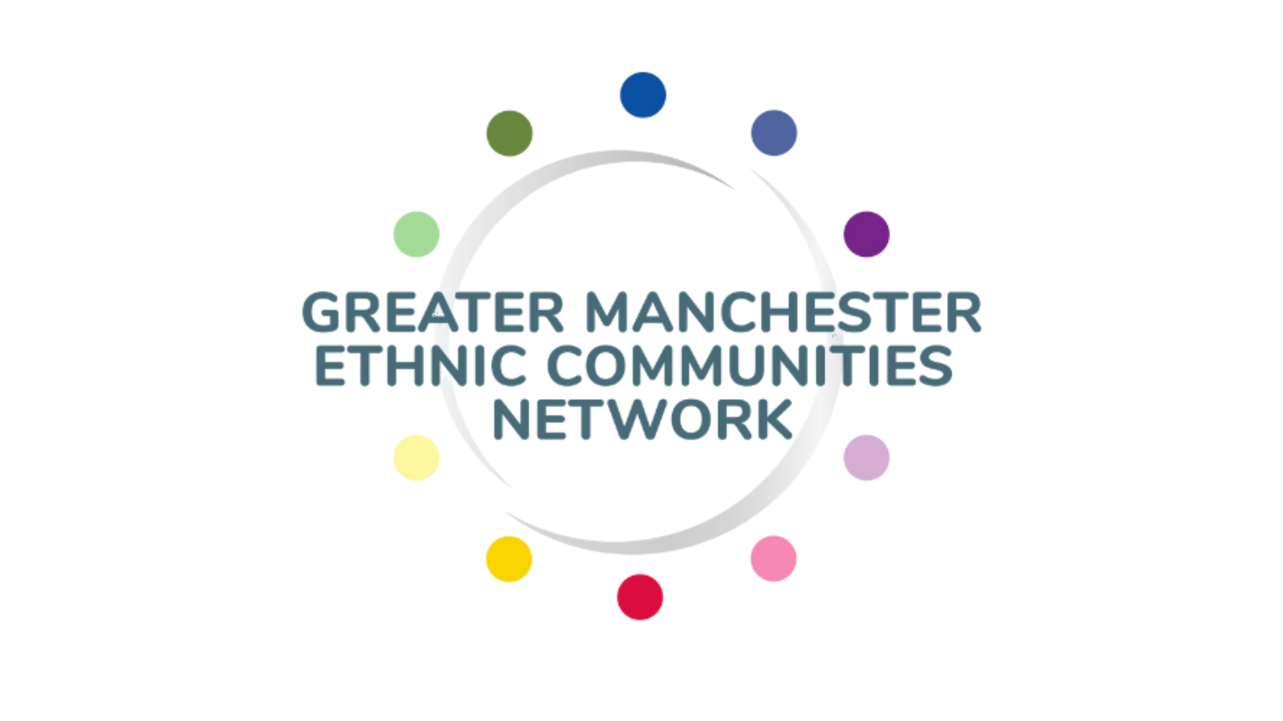
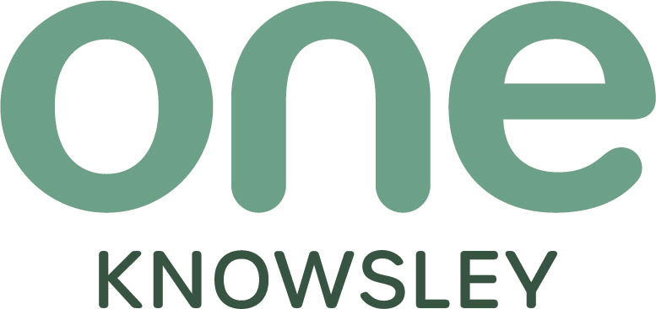

Regional Advisory Group - Expression of Interest
The Phoenix Way (TPW) is a grant-making initiative designed to transform Black and ethnic minority communities. Established in partnership with six regional leads and supported by The Youth Endowment Fund, Chanel, and Lloyds Bank Foundation for England and Wales, TPW was created during the Covid-19 pandemic to address structural inequalities faced by Black and racially minoritised communities and community-led organisations in influencing and accessing grant funding in the UK.

Purpose and Vision
TPW is a racial justice movement committed to dismantling systemic barriers that prevent Black and racially minoritised communities from influencing and accessing funding. By putting communities in the lead, TPW ensures that no community is left behind.

Principal Aims:
- Transform the relationship between funders and Black and ethnic minoritised communities.
- Tackle systemic racial inequalities.
- Develop shared leadership that actively invests in communities and empowers them to make decisions about funding processes, priorities, and allocations.
- Drive transformational change at regional and national levels by applying a racial equity and social justice lens and generating learning that impacts the wider funding ecosystem.

Aim of Regional Advisory Group:
The aim of the Regional Advisory Group is to be a supportive and constructive forum guiding the TPW NW delivery plan to work towards realising achievable systemic change in how grant funding is accessed and allocated to BRM led organisations across the Northwest.
Group member expectations:
All RAG members will be expected to:
- Have a good understanding of Racial Equality and Racial Justice and how these impacts on the lives of local minoritised led organisations and the communities they serve.
- Support and guide the success of the TPW delivery plan.
- Help promote the work of TPW while working closely with the TPW team for their locality and across the Northwest/ national footprint as necessary.
- Declare any conflict of interest at the beginning of each meeting or as soon as the conflict is determined whilst the meeting is taking place
Rules of Engagement:
The RAG will implement the rules of engagement below to enhance its effectiveness and create a supportive environment that encourages growth and innovation from the TPW NW team.
- Confidentiality: RAG members will agree to keep sensitive discussions private within the RAG and the TPW NW Team while allowing open and honest discussion without fear of any information being leaked outside of this group.

- Presence: RAG members must commit to full presence and engagement during meetings and help foster productivity.

- Open communication: RAG members and TPW NW team will create a safe space for all members to participate without fear of judgement through active listening and valuing diverse perspectives.

- Commitment to challenges: RAG members and TPW NW team will commit to support each other through difficult discussions and challenging conversations.

- Accountability and support: RAG members will hold themselves accountable for their actions and decisions whilst being supportive of each other and create an environment of learning from errors instead of creating a blame culture.

- Equal participation: RAG members will establish a culture that ensures all members have an opportunity to contribute.

- Performance not personalities: RAG members will foster a collaborative environment where the focus is on tasks in hand instead of personalities.

- Agree to disagree: RAG members will allow for differing opinions and establish a protocol where in cases of no consensus, the chair will have a double vote to reach a positive outcome.

Meeting frequency/attendance:
The RAG will have 4 mtgs per year, attendance is required by all RAG members unless there are extenuating circumstances.
Meeting dates will be circulated and agreed upon at the beginning of each year. This will allow RAG members sufficient time to adjust their diaries to accommodate RAG meetings.

TPW NW Offer:
Inclusive North as the lead for TPW NW will:
- Recruit 3 RAG members from each subregion;
- Induct and be the main line of contact for the RAG members;
- Administer all meetings including the agenda, minutes of meeting, TPW NW reports on progress/issues, and any actions required;
- Provide any training or support linked to the TPW NW/National Programme as required;
- Pay RAG members a set fee of £100 per meeting attended.
*If you feel you are the person who meets the above requirements and have an interest in joining the regional Advisory Group, please complete the expression of interest form below highlighting your delivery of/interest in similar work, and how you meet the requirements of the Regional Advisory Group.

If you need to discuss or have any query, you can contact: Rehmat Hasham
or Nadia Shiraz - Tel: 01254 392974
Email: projects@inclusivenorth.org.uk

*Deadline for EOI: Monday 15th June, 2026 by 10am

Expression of Interest Form:

Name:
Organisation Name (if applying as part of an organisation):
Summary description of what your organisation does:
Address: |  | Post Code:
Telephone Number: |  | Mobile Number:
Email Address:
Website:

Q1. Please state your interest in joining The TPW NW Regional Advisory Group? *
Q2. Do you have previous experience of being on similar groups/ networks? If so, please explain the purpose of the group/ network and your role in it? *
Q3. Please state what you will bring to the RAG and what you hope to gain from your engagement on a personal and professional level? *
Other comments: (eg availability, additional needs etc that may affect your full participation and how we can support full commitment)

